DynamoDB lab 2:

To create a DAX (DynamoDB Accelerator) cluster in AWS, you can follow these steps:

1. Sign in to the AWS Management Console: Open the AWS Management Console in your web browser and sign in with your AWS account credentials.

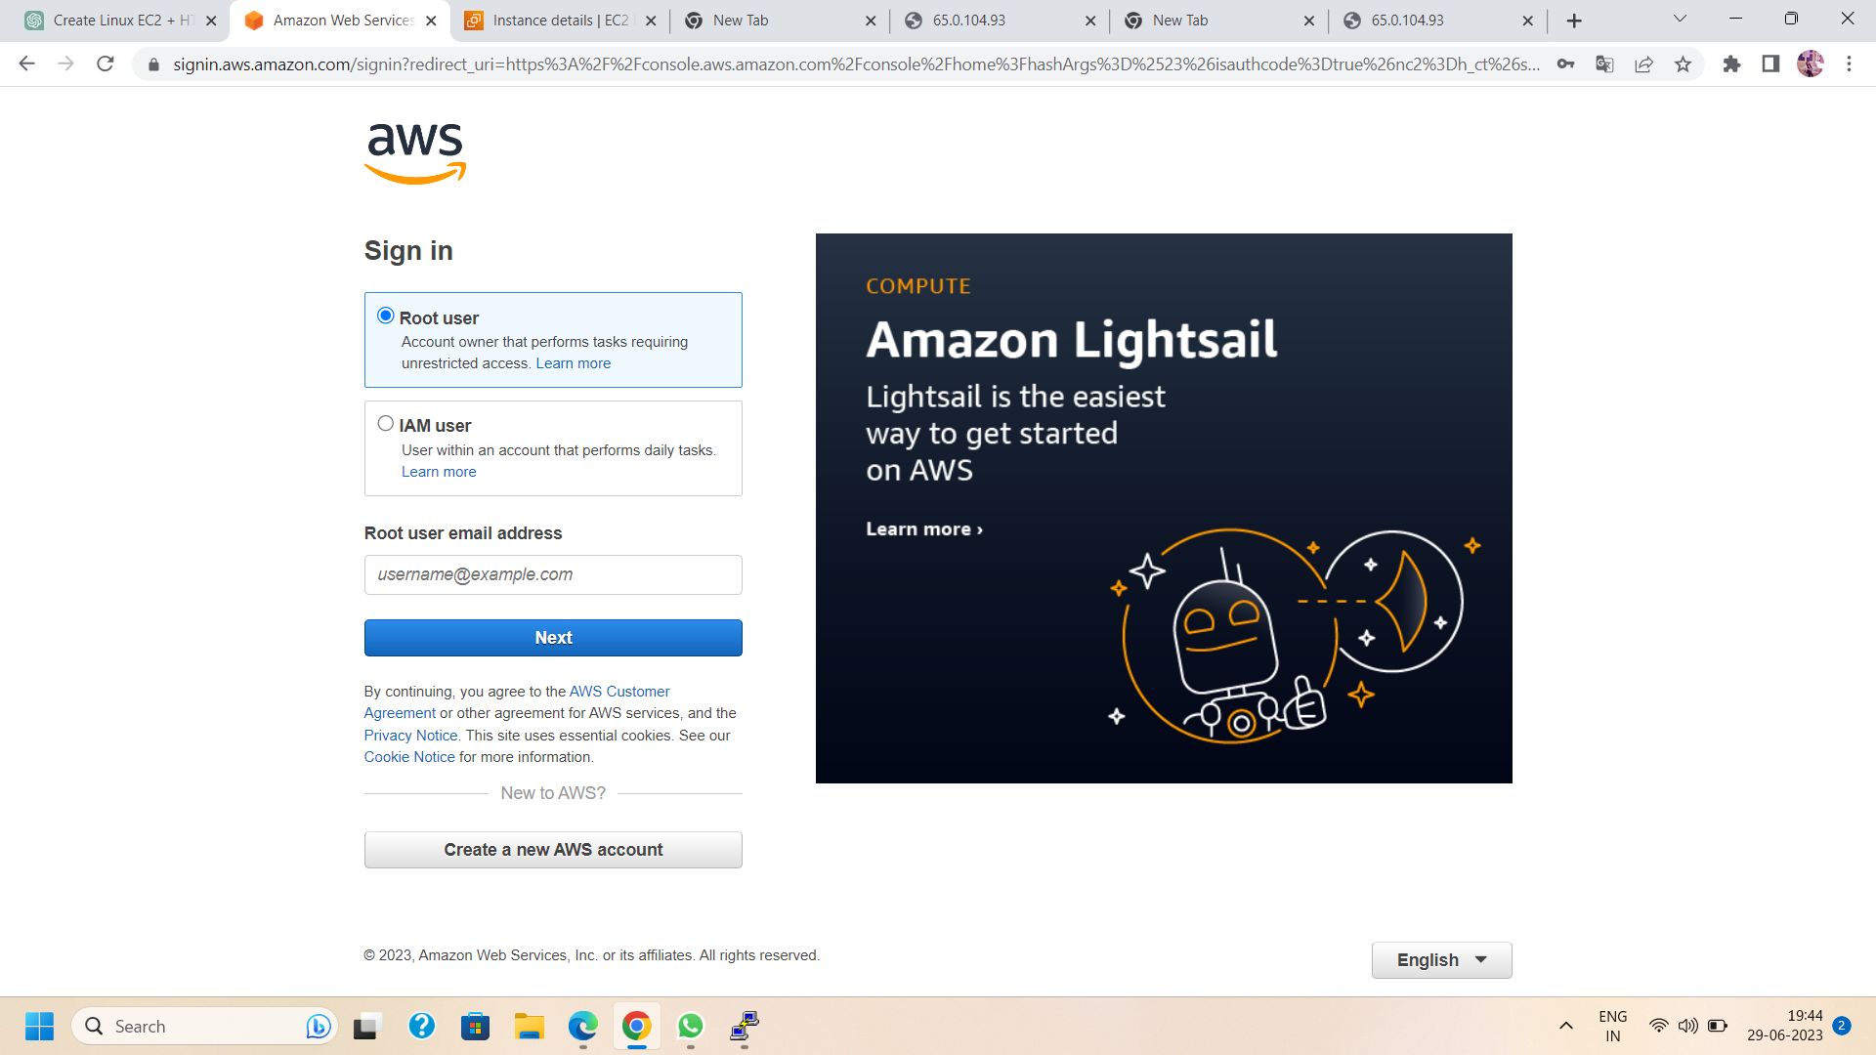

1. Open the DAX service: Once you are logged in, type "DAX" in the search bar at the top and select "DynamoDB" from the list of services that appear.

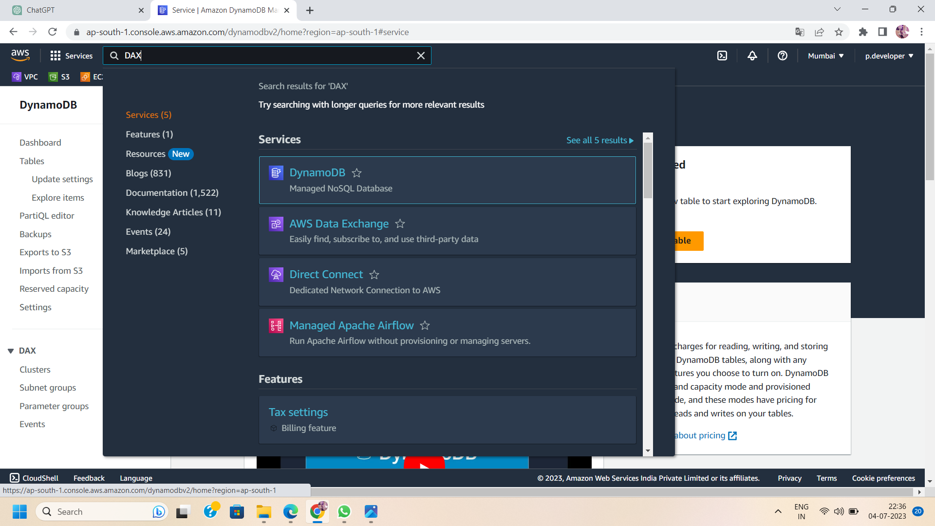

1. Create a DAX cluster: In the DynamoDB console, click on the “DAX" option and then choose “create cluster”.

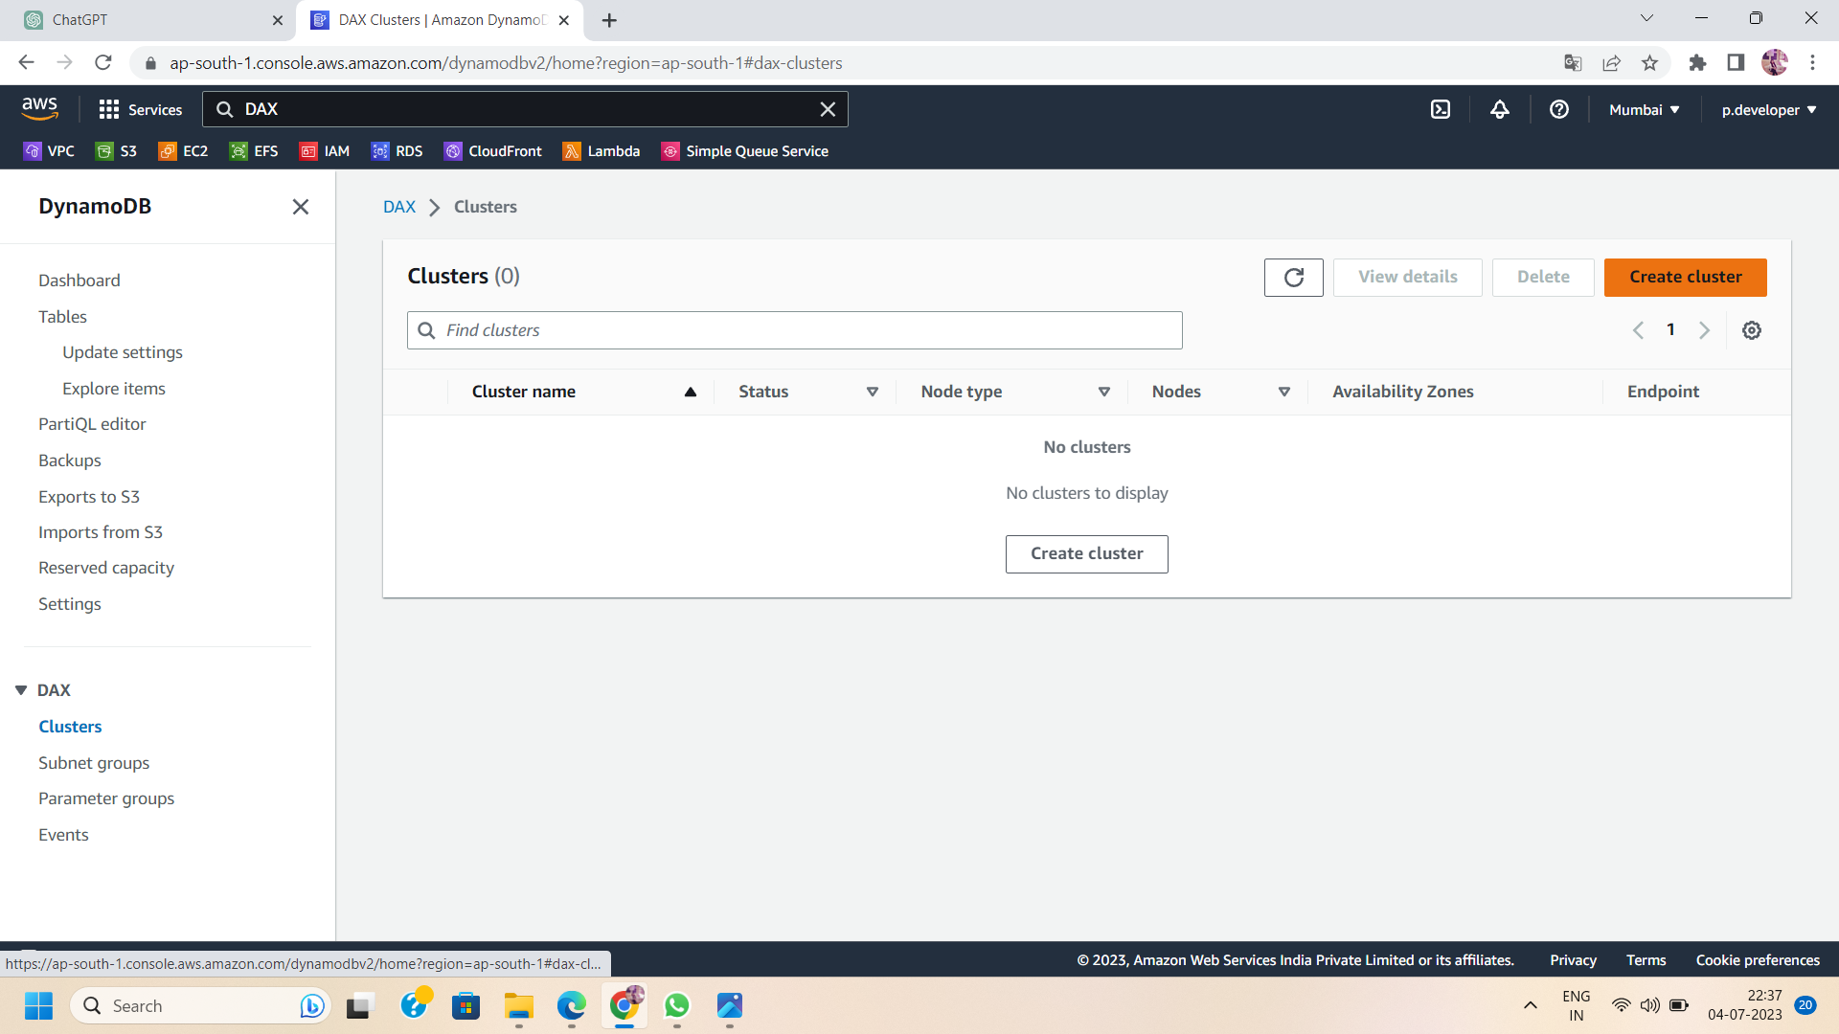

1. Configure the cluster settings:
   1. Provide a unique name for your DAX cluster.

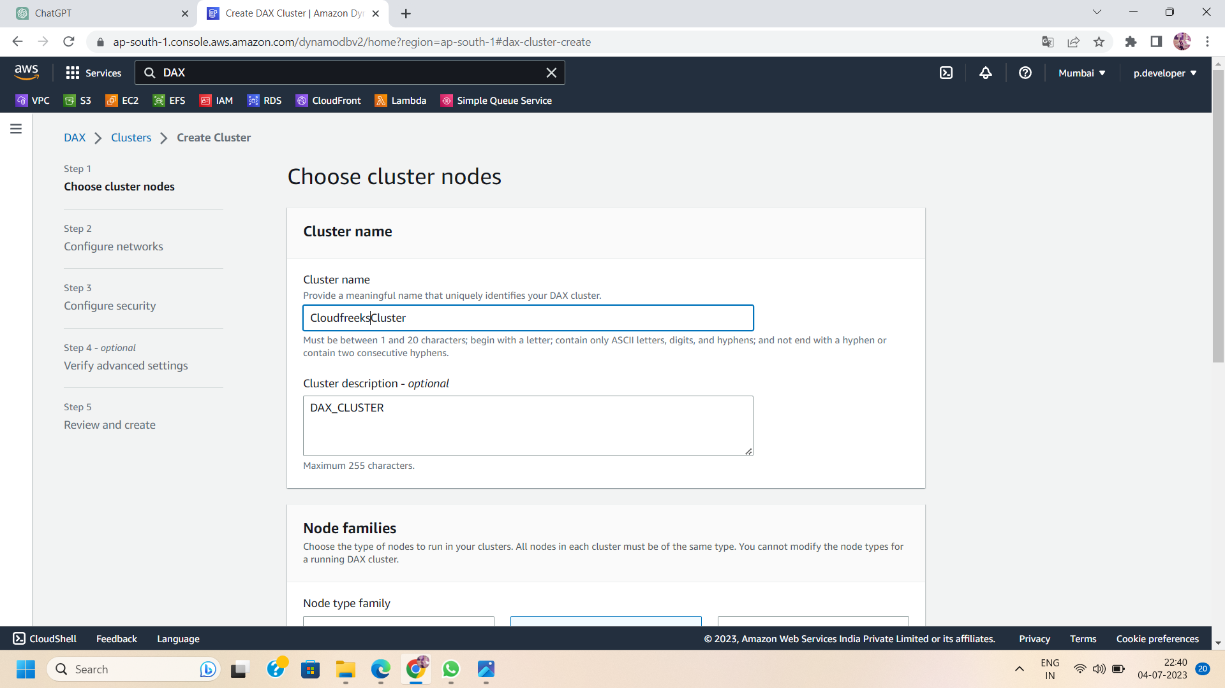

* 1. Specify the number of nodes you want in the cluster (nodes represent the amount of memory and compute capacity).

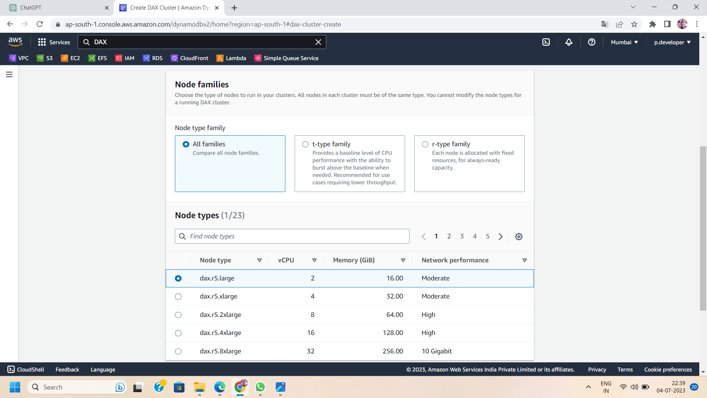

* 1. Set the subnet group that determines the VPC and subnets in which the cluster will be deployed.

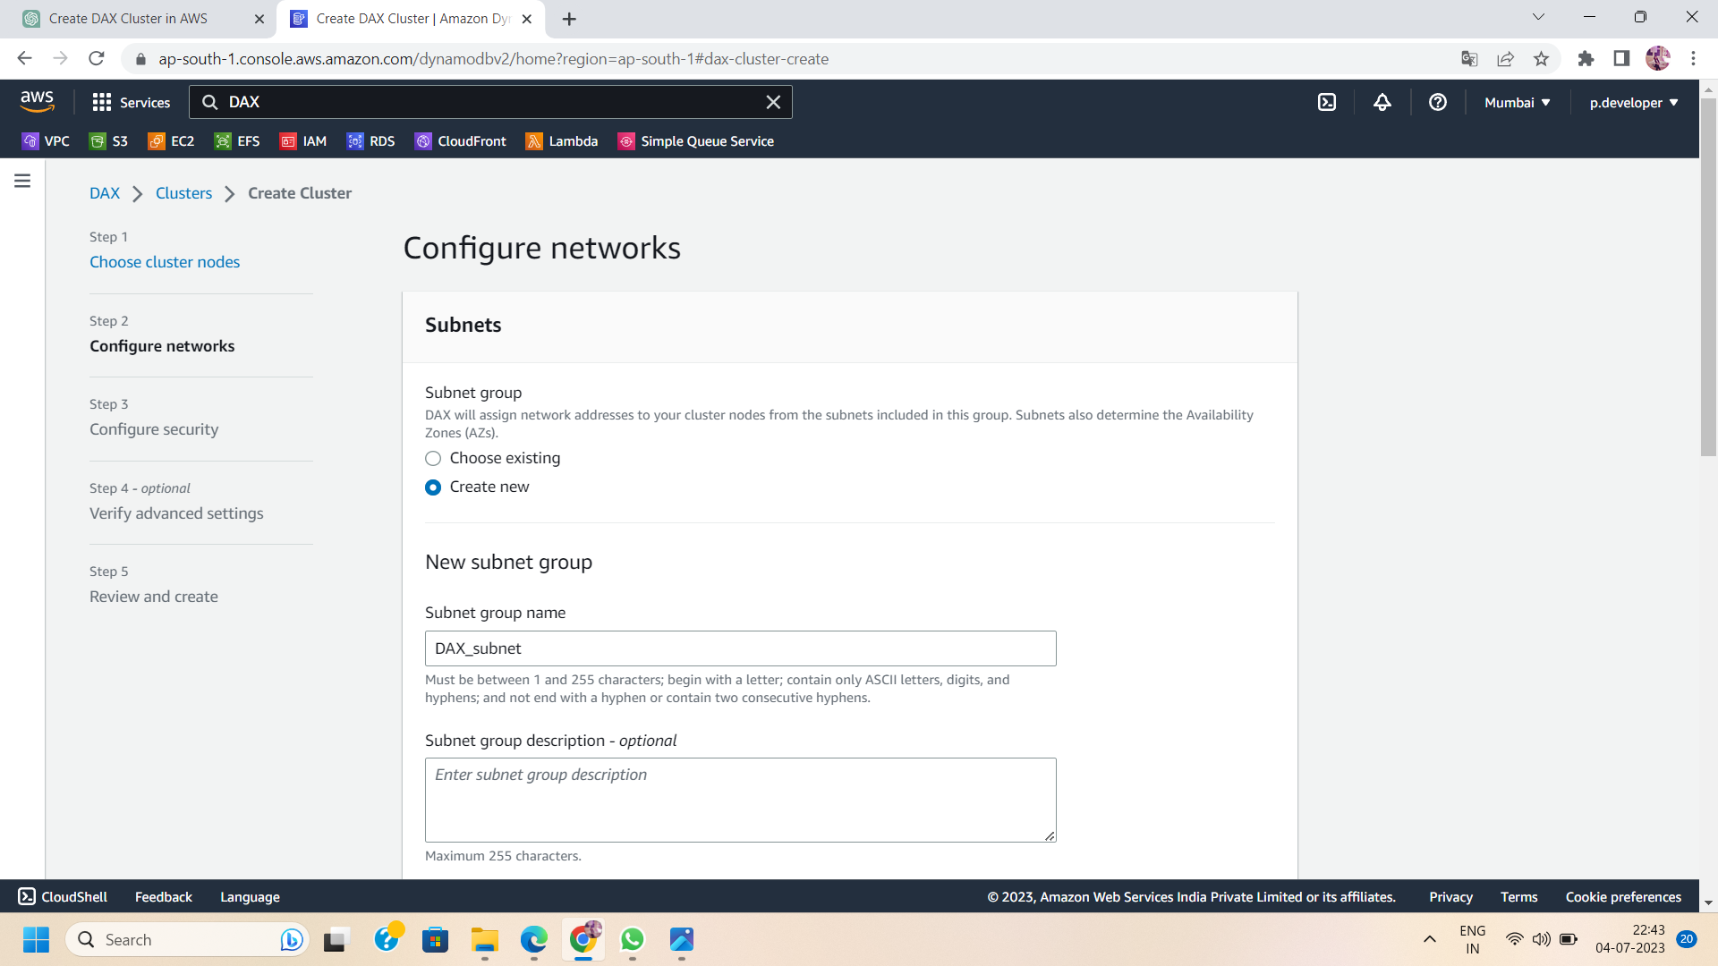

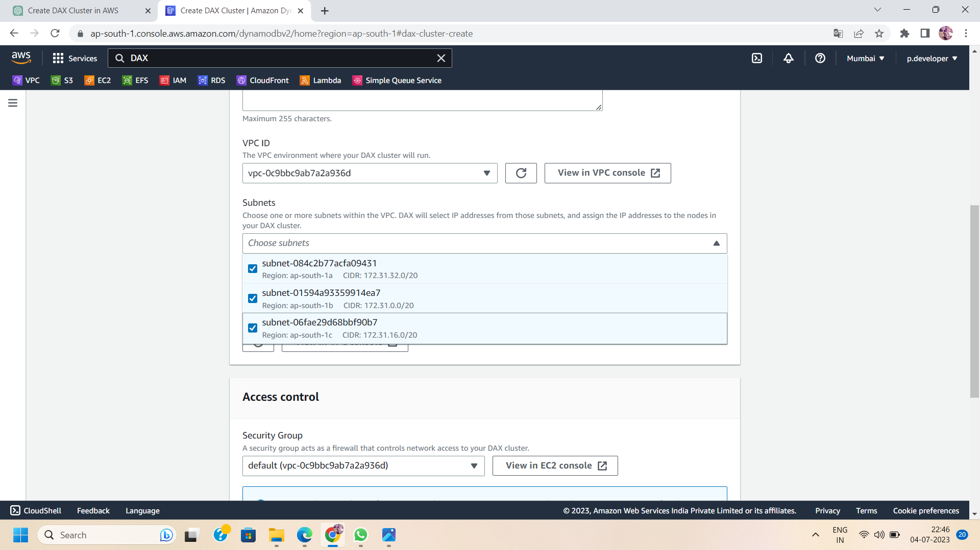

1. Configure advanced settings:
   1. Choose the VPC security groups that control inbound and outbound traffic for your cluster.

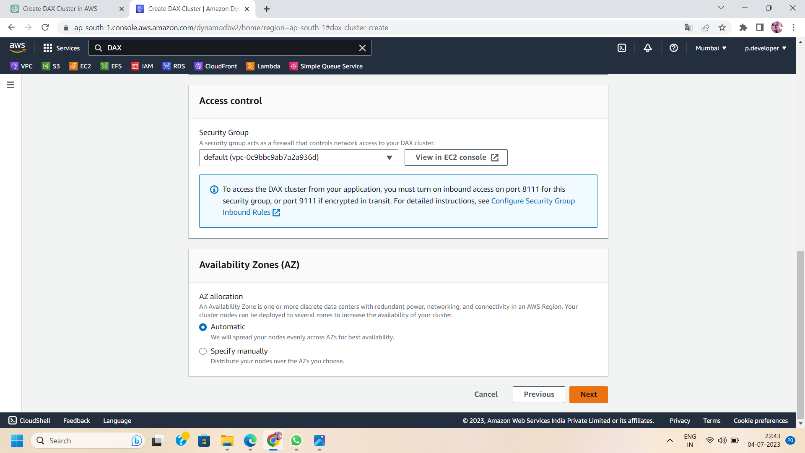

* 1. Specify a parameter group if you need to modify advanced configuration settings.

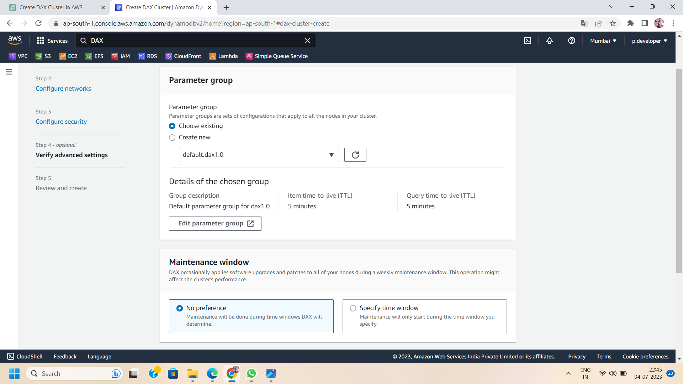

1. Configure IAM roles: Specify the IAM roles that DAX can use to access AWS resources on your behalf or you can create new IAM roles in the cluster that will automatically be created by dynamoDB.

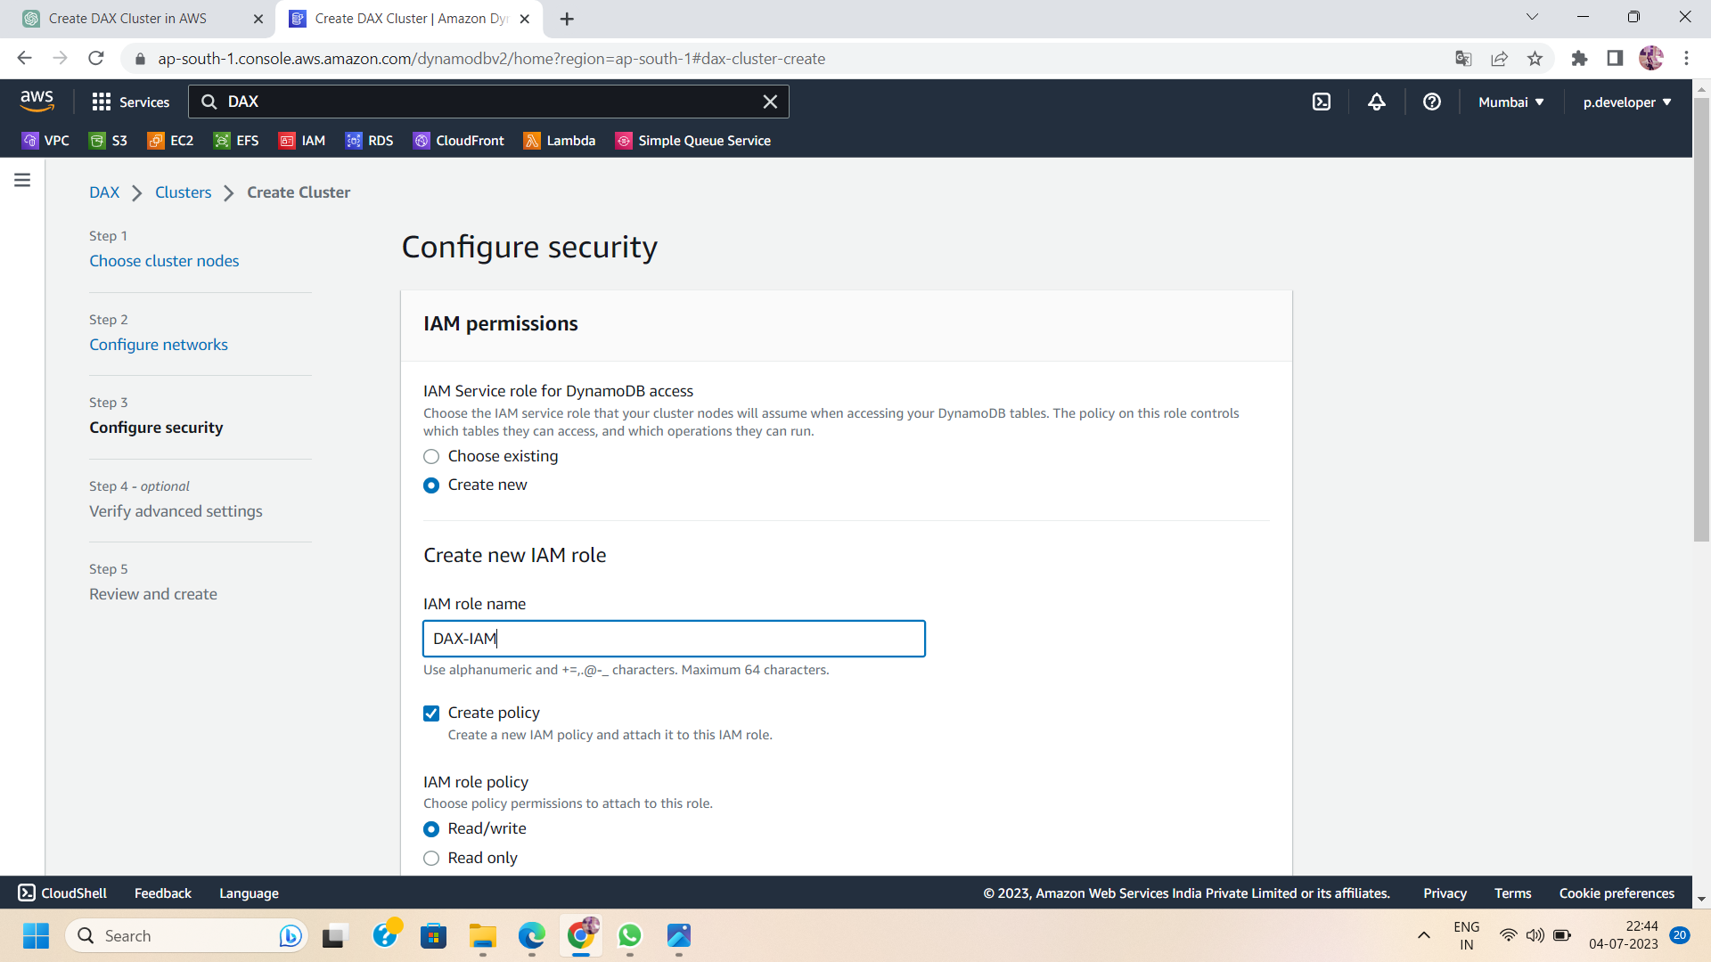

1. Review and create: Review the configuration settings you have provided. If everything looks correct, click on the "Create" button to create the DAX cluster.

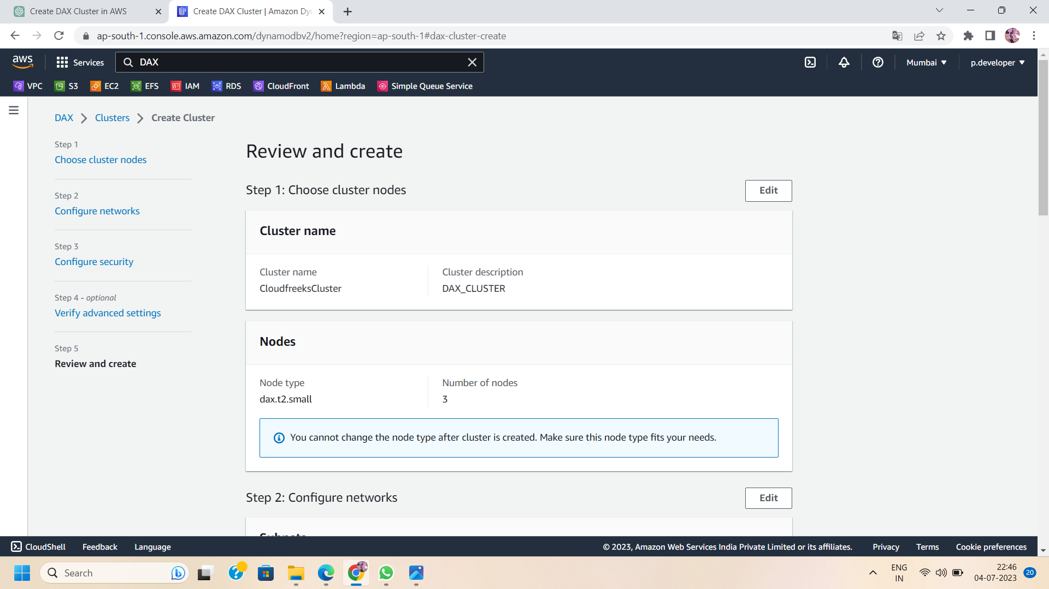

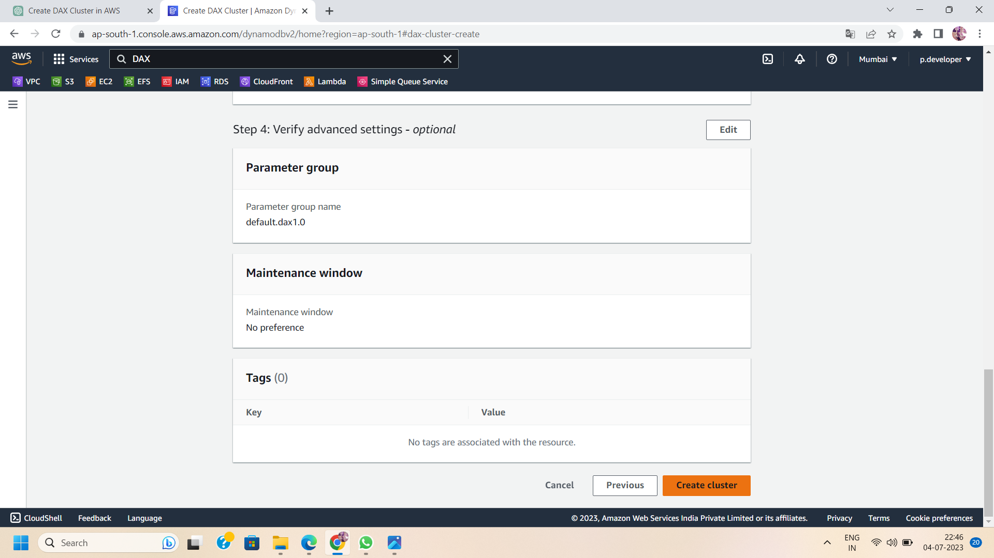

1. Wait for the cluster to be created: The creation process may take a few minutes. You can monitor the progress in the DAX console.

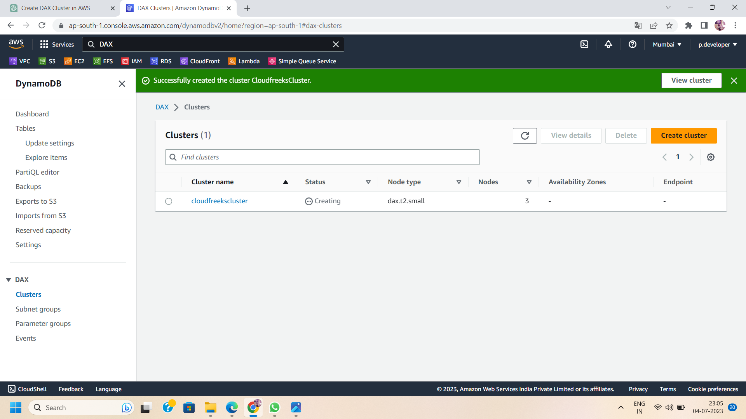

1. Now ,your DAX cluster is successfully created.you can see in the DAX console.

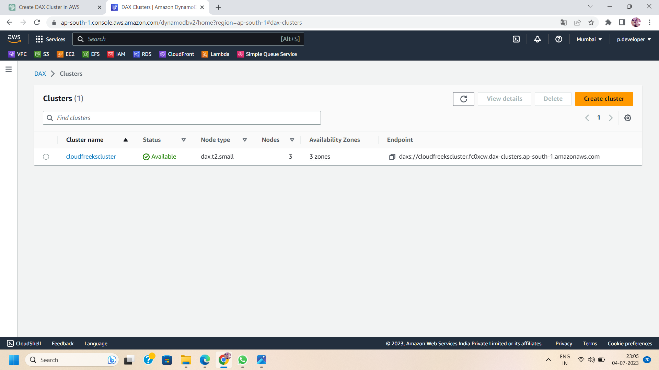

That's it! You have now created a DAX cluster in AWS. Remember to update your application's code to utilize the DAX cluster for improved performance and scalability when accessing DynamoDB data.